SUMMER TRAINING REPORT

ON

Personal Portfolio

Submitted to Guru Gobind Singh Indraprastha University, Delhi (India)
In partial fulfillment of requirement for the award of the degree of

BACHELOR OF TECHNOLOGY

IN

Computer Science Engineering

AT
Delhi Technical Campus, Greater Noida

SUBMITTED BY
Harsh Madhavan
(09518002721)
Sem V
SUBMITTED TO
Mrs. Reeta Mishra
(Assistant Professor)

Department of Computer Science & Engineering

SESSION 2023-2024



DELHI TECHNICAL CAMPUS, GREATER NOIDA

(Affiliated by Guru Gobind Singh Indraprastha University, New Delhi)

CERTIFICATE

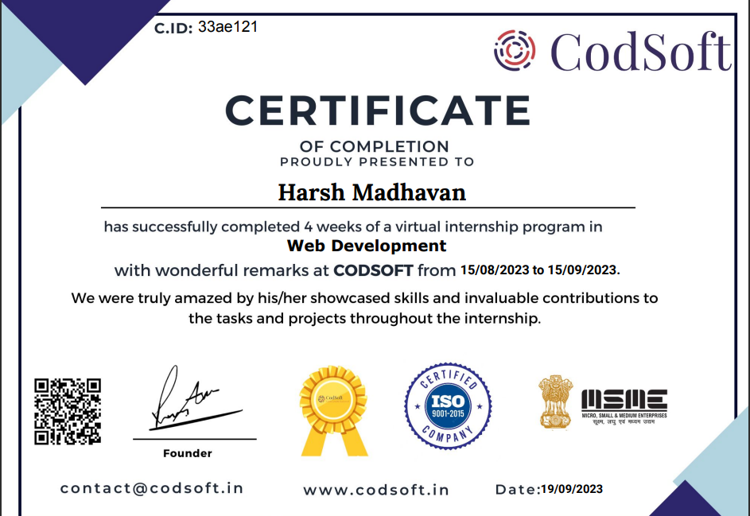

ACKNOWLEDGEMENT

Training is an integral part of engineering curriculum providing Engineers with first hand and practical aspects of their studies. It gives me great pleasure in completing my Summer Internship (Virtual) at CodSoft under Web Development Program and submitting the training report for the same.
I record my sincere thanks to the Director, for providing me an excellent opportunity to undergo training in his esteemed Organization through which I could gain an exposure to the Development environment and getting acquainted with the Cyber Security.
I wish to express my deep sense of gratitude and obligation to, CodSoft for its valuable guidance, supporting me constantly and channelizing my work toward more positive manner.

Name: Harsh Madhavan Name: Mr.s Reeta Mishra
Semester: 5th Designation: Assistant Professor
Enrollment Number: 09518002721

Signature of the Faculty

ABOUT THE COMPANY


CodSoft, a distinguished IT services and consultancy enterprise, is dedicated to pioneering innovative solutions for businesses. Driven by a deep-seated belief in the transformative potential of technology, CodSoft is unwavering in its commitment to shaping the future through cutting-edge software solutions. The company's investment in the industry's future is exemplified through its robust internship program.

At CodSoft, we recognize that practical knowledge is the linchpin for success in the dynamic tech landscape. Our internship program stands as a testament to this ethos, offering hands-on learning experiences, live projects, and real-world examples. Aimed at empowering students lacking essential skills, the program is a gateway to the practical application of theoretical knowledge.

The CodSoft team comprises industry experts passionately dedicated to equipping interns with the tools they need to thrive in their careers. We foster an inclusive and supportive environment that encourages continuous learning, personal growth, and creative thinking. Our internship initiative not only contributes to the professional development of aspiring technologists but also aligns with CodSoft's vision of being at the forefront of technological advancement, driving positive change in the IT landscape.

Website:-
http://codesoftinfotech.com/

Industry:-
IT Services and IT Consulting

ABSTRACT OF PROJECT

The Personal Portfolio Website project is a comprehensive exploration into the development of an individual's online presence, encapsulated within a dynamic and visually appealing digital portfolio. This undertaking aims to create a responsive and user-friendly website that showcases the skills, achievements, and personality of the portfolio owner.

Grounded in HTML, CSS, and JavaScript, the project focuses on delivering a seamless and engaging user experience. The website's design prioritizes responsiveness, ensuring an optimal viewing experience across a spectrum of devices. The interface is carefully crafted to present information cohesively, allowing visitors to navigate effortlessly through sections highlighting the individual's professional background, skills, projects, and personal insights.

Beyond the surface-level presentation, the project incorporates interactive elements and multimedia components, injecting vitality into the portfolio. Integrating features such as project showcases, skill demonstrations, and a personalized blog or bio section, the website not only serves as a static representation but as a dynamic platform that evolves alongside the individual's journey and accomplishments.

Emphasizing the significance of personal branding, the project explores design choices that reflect the individual's identity and style. This includes color schemes, typography, and overall aesthetics that contribute to a cohesive and memorable brand image. Additionally, the project ensuring the portfolio is discoverable and leaves a lasting digital footprint.

In conclusion, the Personal Portfolio Website project is a testament to the fusion of technology and personal expression. By leveraging web development tools and design principles, the project seeks to empower individuals in crafting a compelling online presence, amplifying their professional narrative and creating a lasting impression in the digital landscape.

TABLE OF CONTENTS

S. No. | Title | Page No.
1. | Title page | i
2. | Certificate | ii
3. | Acknowledgement | iii
4. | About The Company | iv
5. | Abstract Of Project | v
6. | Table Of Content | vi
7. | List Of Figures | vii
8. | Chapter 1: Introduction  1.1 Introduction  1.2 Objective | 1  1  1
9. | Chapter 2: Project Overview  2.1 Project Description  2.2 Introduction and Target Audience | 2-4  2-3  4
10. | Chapter 3: Technology Used  3.1 HTML  3.2 CSS  3.3 JavaScript | 5-11  5-6  7-9  9-11
11. | Chapter 4: Project Design  4.1 Snapshots  4.2 Implementation of Code | 12-28  12-16  17-28
12. | Chapter 5: Challenges and Solutions | 29-30
13. | Chapter 6: Future and Conclusion  6.1 Future Scope  6.2 Conclusion | 31-33  31-32  33
14. | References | 34
15. | Minor Project  7.1 Problem Statement  7.2 Introduction  7.3 Abstract  7.4 Components  7.5 Snaps  7.6 Problems and Solutions  7.7 Future Scope  7.8 Conclusion | 42-45  43  43  43  43  44  45  45  45
List of Figures

Fig no. Fig Name Page No.

3.1.1 HTML Logo 8
3.2.1 CSS Logo 10
3.3.1 JavaScript Logo 13
4.1.1 Home Page 12
4.1.2 About Page 13
4.1.3 Service page 14
4.1.4 Contact Page 15
4.1.5 Footer 16
4.2.1 HTML Code 17-21
4.2.2 CSS Code 22-27
4.2.3 JS Code 28
7.5 Currency Converter 44

